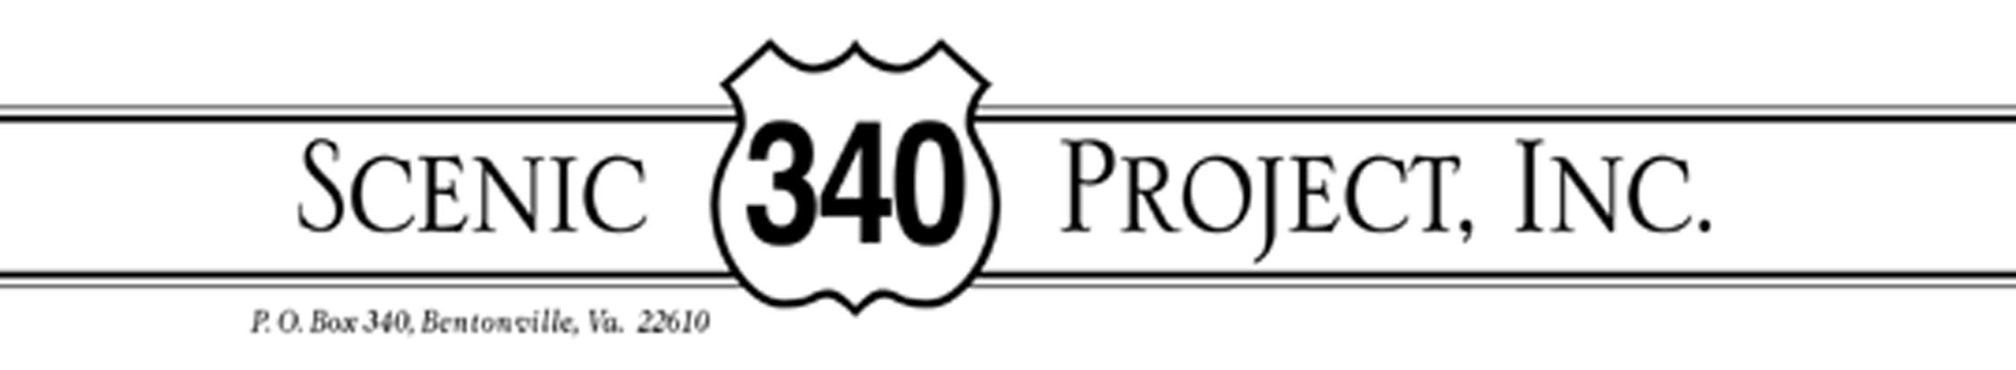

January 17, 2018

Dear Friends and Neighbors,

This brings our heartfelt wishes for a peace-filled, health-filled 2018. Given the deep political divide in our nation, I’m grateful that our small group (whatever your political affiliation) shares the love of our place and the will to protect it. I have no doubt that eventually new threats will arise and we will need to lace up our combat boots, but this past year we have enjoyed a lull and have put our energy into planting and planning for the future.

First, Planting: Of the 210 trees planted along our corridor in the fall of 2016, our 2017 fall inspection showed that about 70% had survived. However, the fall drought may have taken a toll. Despite the drought, we went ahead with more tree-planting but (hoping for rain) waited till December to plant an additional 300 trees at Gooney Creek, Overall Creek, and between Compton and Rileyville. The 2017 mix of trees will include more redbud. Anyone who would like to help out with a spring survey of survivors, let me know.

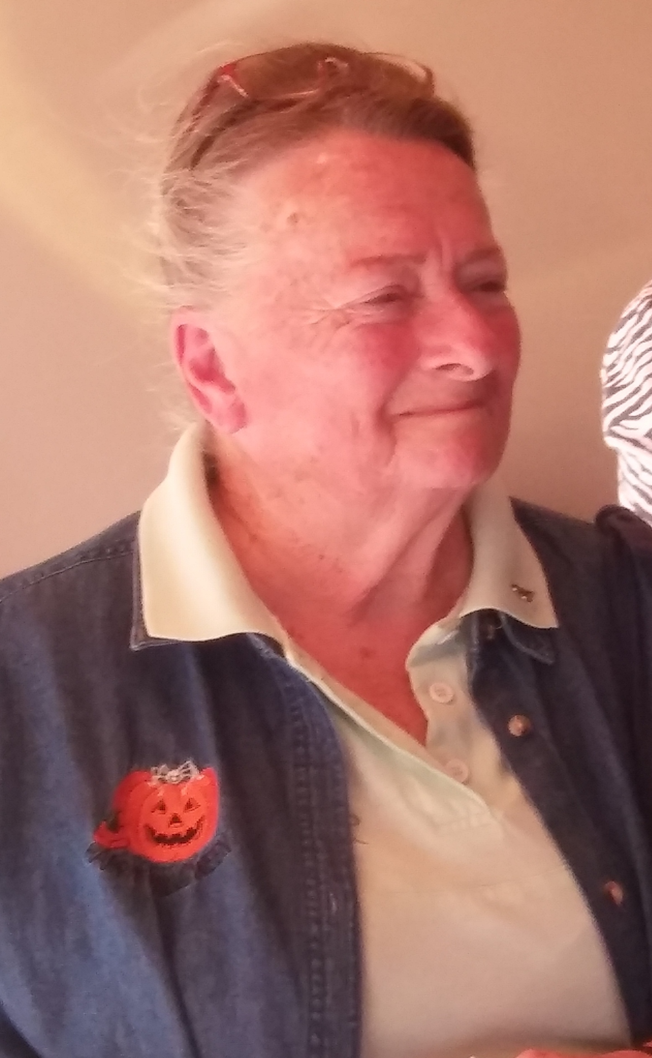
Secondly, Planning: With an eye to encouraging conservation easements along the river, we initiated a purchase of development rights (PDR) program in Warren County. Working with the county, the state, and the Virginia Conservation Council (VCC). Margie Guy is the first landowner to participate in the program. She has sold the development rights on her 50 acre riverfront property to the County which holds the easement on it. Margie has dedicated the easement to the memory of her daughter Dawn. We expect that the complex and seemingly endless paperwork will be completed this month. While we hope other landowners will follow Margie’s lead, I have to say the process is actually slower than molasses in January!

Planning #2: We have started to think about future possibilities for Scenic 340 Project. Your input is welcome. Your contributions are also welcome: they keep us going!
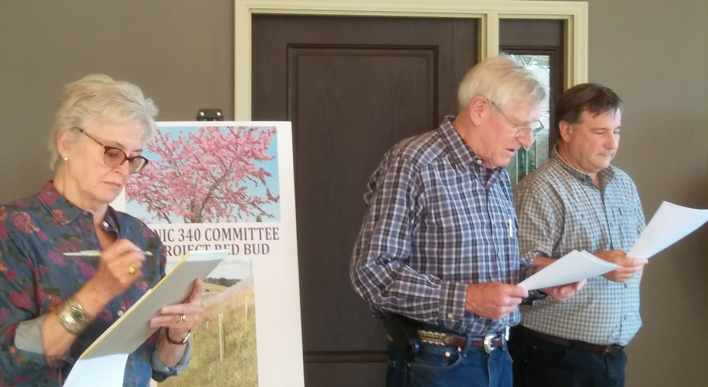
Meanwhile, at our annual 2017 meeting (hosted this year by Harry and Valeri Heard at their beautiful place above the river), your board played its annual game of musical chairs. Paula Atwood landed in the President’s seat while Tom Lockhart slid safely into VP. Fred and I plonked down the same old chairs: Fred is Treasurer and I continue on as Secretary and your scribe.
Christine Fred & Tom
Warmly, christine

